# Daily Return Histogram from Backtest

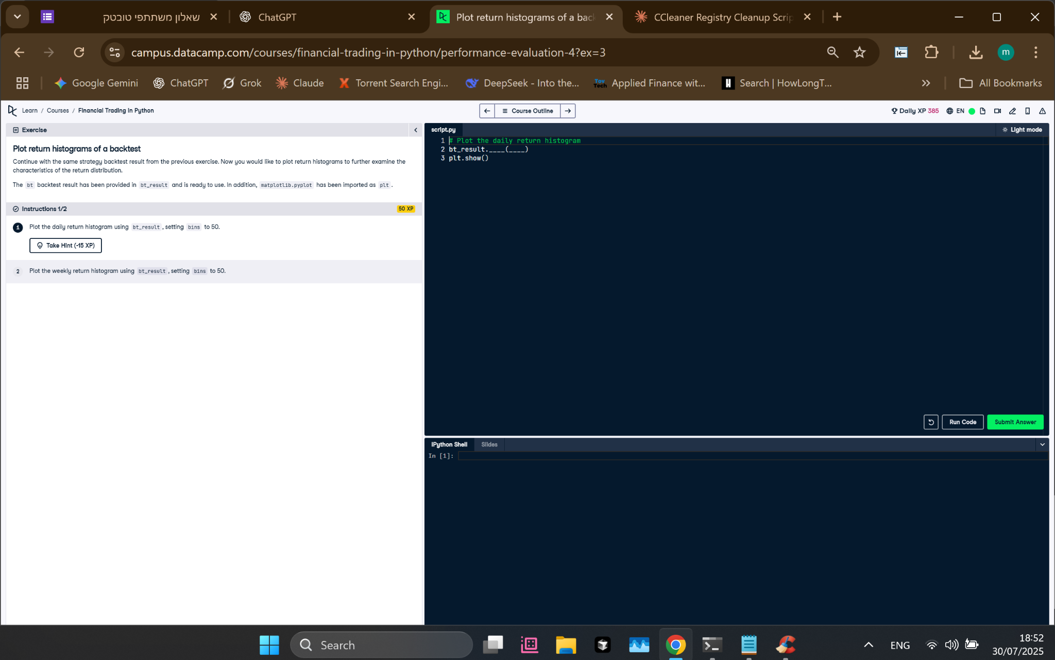

## Python Code

# Plot the daily return histogram  
bt_result.plot_histograms(bins=50)  
plt.show()

## Explanation (Simple Words)

Instead of using plot.hist (for DataFrames), we use plot_histograms() directly on the bt_result object. This method is made to show return distributions from a backtest. Setting bins=50 splits the return values into 50 parts for better detail. plt.show() shows the chart.